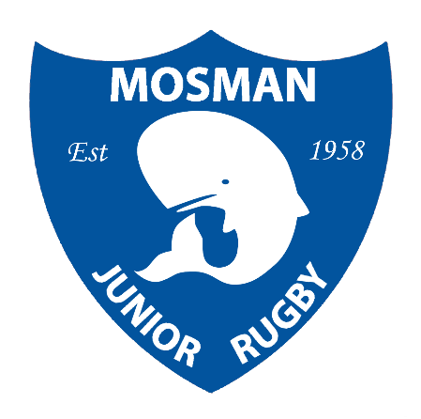
Mosman Junior Rugby Club Song

Hello Hello how do you do
We are the boys in blue and blue

We play them here
We play them there
We play our rugby hard and fair

We raise our game up to the sky
To keep the Whales flag flying high

Hello Hello how do you do
We are the boys in blue and blue
We are the Mosman Junior Rugby Club

Hello Hello how do you do
We are the boys in blue and blue

Mosman!
Mosman!
Mosman are we
And Mosman
We will always be…

